Exploratory Data Analysis (EDA) Report
Dynamic Pricing Strategies for Fitness Classes Based on Demand, Time, and Location

1. Introduction
Objective
The objective of this Exploratory Data Analysis (EDA) is to understand booking patterns, customer demand, pricing trends, and location-wise performance of fitness classes. This analysis helps identify the key factors affecting class demand and provides insights for developing a dynamic pricing strategy based on demand, time, and location.

2. Dataset Overview
The dataset contains information about fitness classes conducted across different activity sites. It includes booking details, class capacity, class price, activity information, session timing, and booking dates.
The data was explored to understand customer booking behavior, identify high-demand classes, compare activity sites, and analyze pricing patterns.
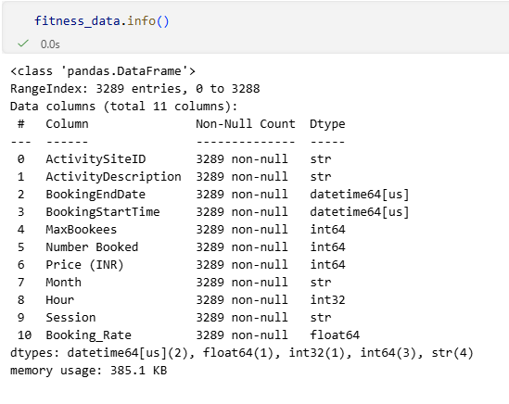

3. Statistical Summary
A statistical summary was generated for all numerical variables such as Maximum Booking, Number Booked, Price (INR)
The summary provides information about:
- Count
- Mean
- Standard Deviation
- Minimum Value
- Maximum Value
- Quartiles (25%, 50%, 75%)
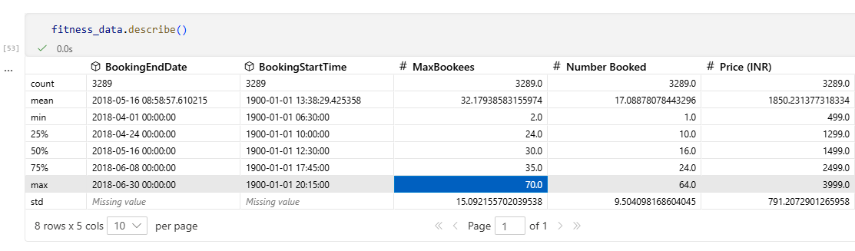
This helps in understanding the overall distribution of the numerical variables before performing further analysis.

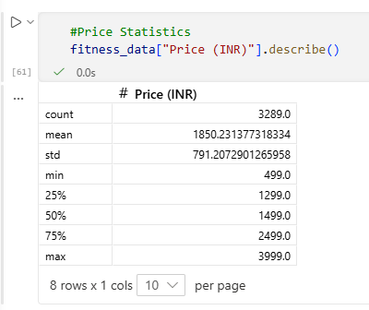
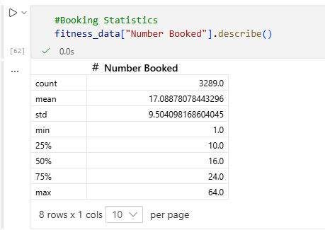

4. Demand Analysis
Demand analysis helps identify which fitness classes, sessions, and locations receive the highest customer bookings. Understanding demand patterns is important for implementing dynamic pricing, where prices can be increased during high-demand periods and reduced during low-demand periods.
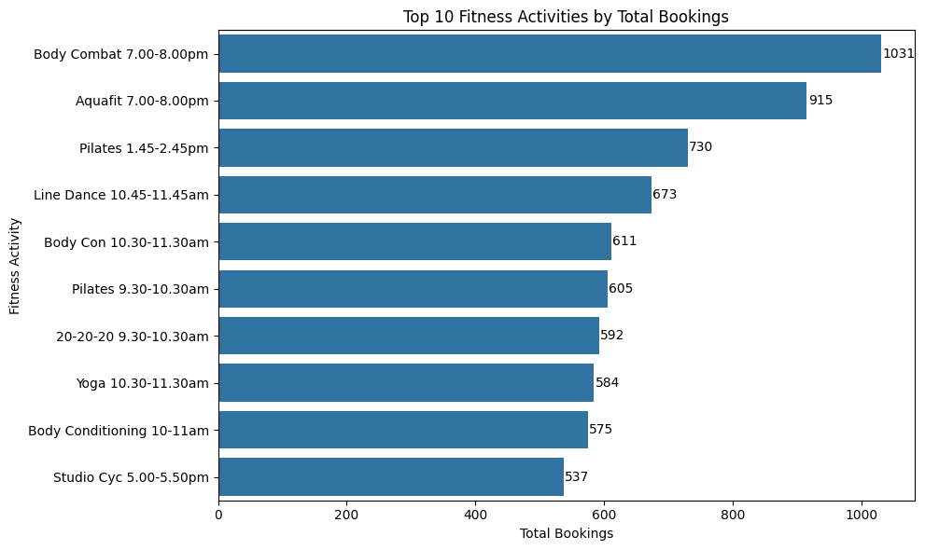
4.1 Top 10 Fitness Activities by Total Bookings

- Body Combat (7:00–8:00 PM) recorded the highest total bookings among all fitness activities.
- Aquafit and Pilates also showed strong customer demand.
- The top activities consistently attracted more participants than other classes.
- These high-demand activities are suitable candidates for premium or dynamic pricing.

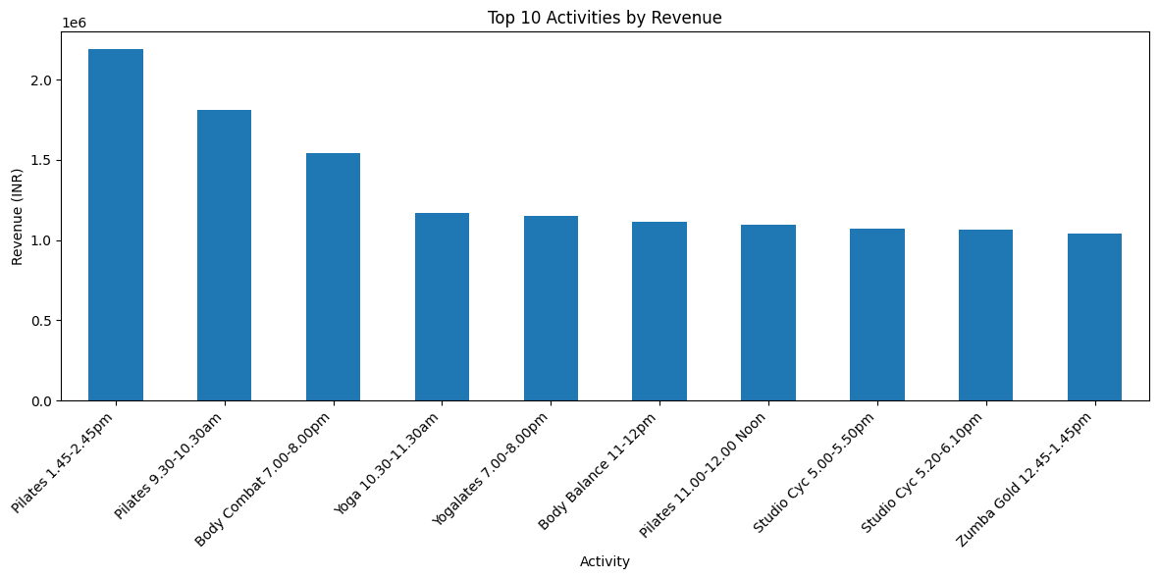
4.2 Top 10 Fitness Activities by Total Revenue

- Pilates (1:45–2:45 PM) generated the highest revenue among all fitness activities.
- Pilates (9:30–10:30 AM) and Body Combat (7:00–8:00 PM) also contributed significantly to total revenue.
- High-revenue activities indicate strong customer demand and profitability.
- These activities are suitable candidates for dynamic pricing and additional session allocation.

4.3 Class Capacity vs Booking

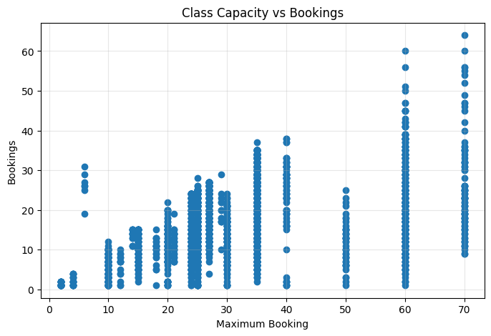

- Classes with larger booking capacity generally received more bookings.
- However, not all high-capacity classes achieved full bookings, indicating variations in customer demand.
- Some lower-capacity classes also showed good occupancy.
- This suggests that customer demand depends on factors beyond capacity, such as activity type, timing, and popularity.

Business Insight
The demand analysis shows that some fitness activities receive significantly more bookings than others. Popular classes can be priced slightly higher during peak demand, while low-demand classes can be promoted with discounts or special offers. This demand-based pricing strategy can increase both revenue and class occupancy.

5. Time Analysis
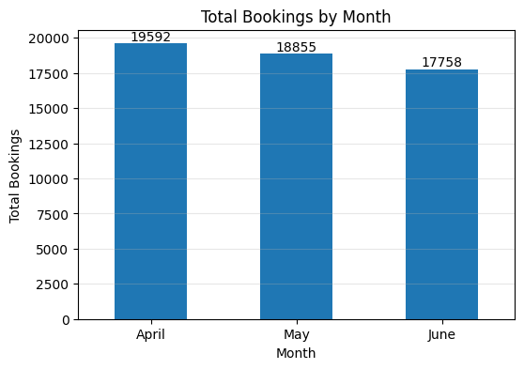
Time plays an important role in customer booking behavior. Analyzing booking trends across different months and sessions helps identify peak demand periods, which can be used to implement time-based dynamic pricing.
5.1 Total Bookings by Month

- April recorded the highest number of bookings (19,592), followed by May (18,855) and June (17,758).
- A gradual decline in bookings is observed from April to June.
- This indicates that customer demand decreased slightly over the three-month period.
- Higher-demand months may support premium pricing, while lower-demand months may benefit from promotional offers.

5.2 Total Bookings by Session
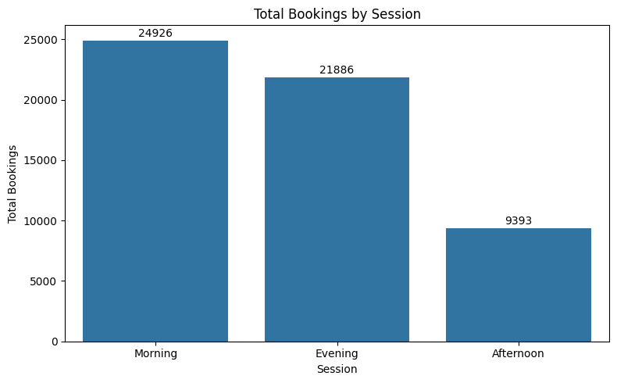

- Morning sessions received the highest number of bookings (24,926).
- Evening sessions recorded the second-highest demand (21,886).
- Afternoon sessions had the lowest bookings (9,393).
- These results indicate that customers prefer morning and evening fitness classes.
- Dynamic pricing can be applied by charging higher prices during high-demand sessions and offering discounts during low-demand sessions.

5.2 Total Bookings by Session
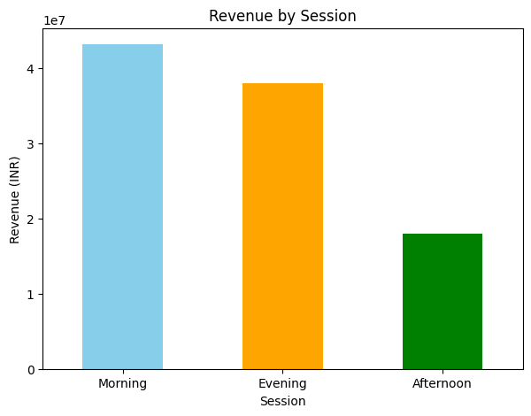
- Morning sessions generated the highest total revenue.
- Evening sessions also contributed significantly to overall revenue.
- Afternoon sessions generated the lowest revenue among all sessions.
- Morning and evening sessions are suitable for premium pricing, while afternoon sessions may benefit from promotional offers to increase demand.

Business Insight
The time analysis indicates that customer demand is highest during morning and evening sessions, while afternoon sessions have lower bookings. The fitness center can apply higher prices during peak hours and offer discounts during off-peak hours to improve bookings and maximize overall revenue.

6. Location Analysis
Location plays an important role in customer demand and pricing. Analyzing bookings and average prices across different activity sites helps identify high-performing locations and supports location-based dynamic pricing decisions.
6.1 Activity Sites by Total Bookings
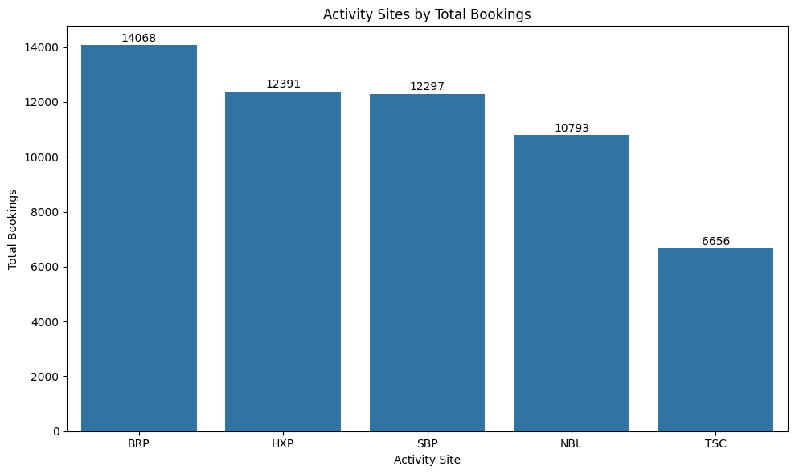

- Booking demand varies across different activity sites.
- Some sites consistently receive significantly higher bookings than others.
- High-performing locations indicate stronger customer demand and can support premium pricing.
- Low-performing locations may require promotional offers or marketing efforts to increase participation.

6.2 Average Class Price by Site
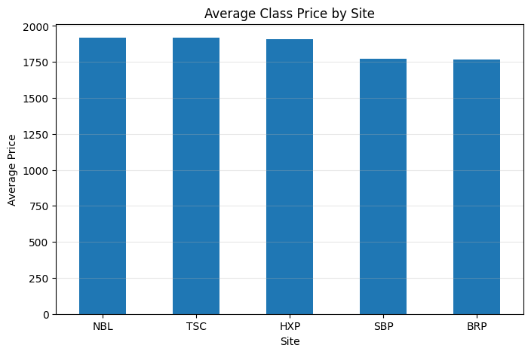
- Some locations have higher average prices, indicating a premium pricing strategy.
- Other sites maintain relatively lower prices to attract more customers.
- These differences suggest that pricing can be optimized based on location-specific demand and customer preferences.

6.3 Revenue By Site

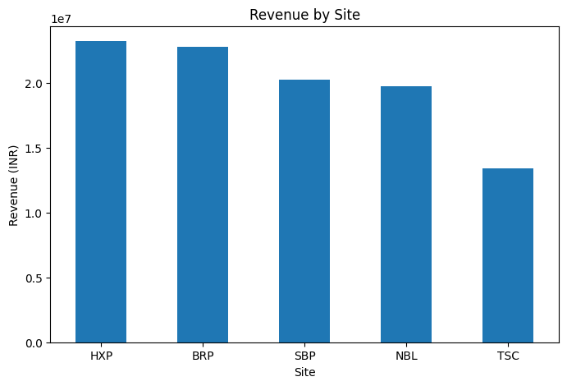
- HXP generated the highest total revenue among all fitness locations.
- BRP was the second-highest revenue-generating site.
- SBP and NBL showed similar revenue performance.
- TSC generated the lowest revenue, indicating an opportunity for promotional campaigns or additional classes.

Business Insight
The location analysis shows that both customer demand and pricing vary across activity sites. Instead of using the same price for every location, the fitness center can implement location-based dynamic pricing. High-demand locations can charge slightly higher prices, while lower-demand locations can offer discounts or promotional pricing to improve bookings.

7. Price Analysis
Price analysis helps understand the distribution of class prices across different fitness classes. It provides insights into the current pricing strategy and identifies opportunities for implementing dynamic pricing based on customer demand.
7.1 Distribution of Class Price
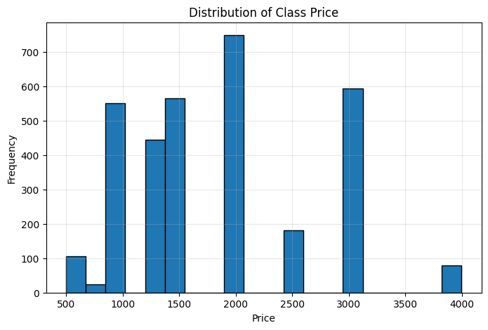
- Most fitness classes are priced within a limited price range, indicating a standardized pricing strategy.
- A few classes are available at higher price points, suggesting premium offerings.
- The price distribution is not completely uniform, showing that different classes are offered at different price levels.
- This variation provides an opportunity to adjust prices based on customer demand, class popularity, and session timing.

Business Insight
The current pricing structure is relatively consistent, with only a few premium-priced classes. Instead of maintaining fixed prices for all classes, the fitness center can adopt dynamic pricing by increasing prices for high-demand classes and offering discounts for low-demand classes. This approach can improve both customer participation and overall revenue.

8. Correlation Analysis
Correlation analysis helps identify the relationship between numerical variables such as class price, booking capacity, and total bookings. It shows whether an increase or decrease in one variable is associated with changes in another.
8.1 Correlation Heatmap
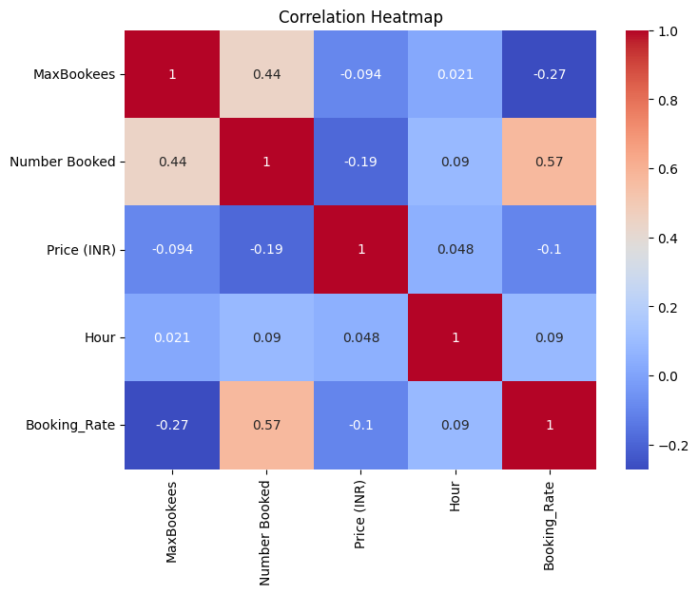

- The heatmap shows the strength of relationships between numerical variables.
- Maximum Booking Capacity has a positive correlation with Number Booked, indicating that larger classes generally receive more bookings.
- Class Price has a weak correlation with Number Booked, suggesting that price alone does not strongly influence customer demand.
- Most other variables show weak to moderate correlations, indicating that multiple factors affect booking behavior.

9. Key Findings

- The exploratory data analysis revealed several important insights related to customer demand, pricing, time, and location.
- Some fitness activities consistently received higher bookings than others.
- Morning and evening sessions had the highest customer demand, while afternoon sessions had the lowest.
- Customer bookings varied across different activity sites, indicating location-based demand differences.
- Class prices were mostly consistent, with only a few premium-priced classes.
- The correlation analysis showed that booking demand is influenced by multiple factors, including capacity, activity type, session timing, and location.

10. Business Recommendations

Based on the EDA findings, the following recommendations can help improve the dynamic pricing strategy:
- Increase prices for high-demand fitness classes during peak booking periods.
- Offer discounts or promotional pricing for low-demand classes and off-peak sessions.
- Apply location-based pricing by charging premium prices at high-performing activity sites.
- Review pricing regularly based on booking trends, customer demand, and seasonal changes.
- Use demand forecasting models to predict future bookings and optimize pricing decisions.
- Monitor customer booking patterns continuously to improve occupancy and maximize revenue.

